ARCHITECTURAL DIAGRAM
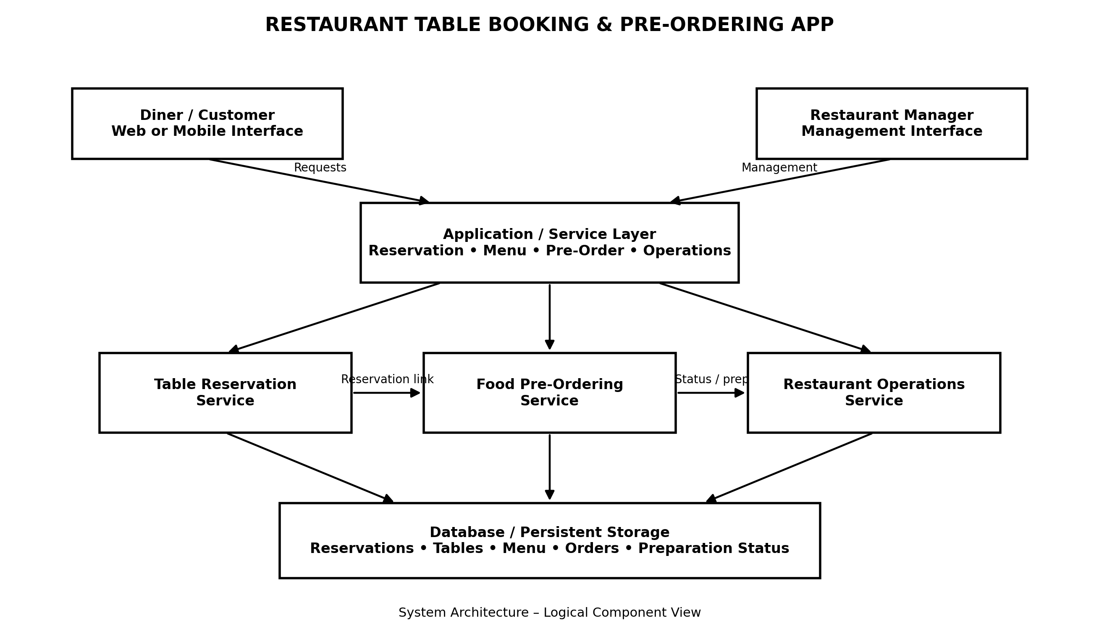
Architecture Components
Component | Purpose
Diner / Customer Interface | Allows diners to view tables, make reservations, browse the menu, customize food items, and place pre-orders.
Restaurant Manager Interface | Allows restaurant staff to monitor table status and restaurant/kitchen operations.
Application / Service Layer | Coordinates reservation, menu, pre-order, and restaurant-operation functions.
Table Reservation Service | Handles table availability, selection, reservation creation, viewing, modification, and cancellation.
Food Pre-Ordering Service | Handles menu browsing, food customization, and pre-order submission.
Restaurant Operations Service | Handles table status, kitchen preparation information, and operational monitoring.
Database / Persistent Storage | Stores reservation, table, menu, order, and preparation-status information.
Architecture Flow
1. The diner interacts with the customer interface to select a table and manage a reservation.
2. Reservation and pre-order requests are processed by the application/service layer.
3. The reservation service manages table availability and reservation information.
4. The food pre-ordering service manages menu selection and pre-order information.
5. Restaurant operations handles real-time table status and kitchen preparation information.
6. All persistent reservation, menu, order, table, and status information is stored in the database.

